VLAN Configuration Using Cisco Packet Tracer
Basic VLAN • Inter-VLAN Routing • VLAN with DHCP

1. Basic VLAN Configuration

1.1 Objective
To create VLAN 10 and VLAN 20 on a Cisco 2960 switch, assign PCs to the appropriate VLANs, and verify communication within the same VLAN and isolation between different VLANs.

1.2 Network Topology
Cisco 2960 Switch
+---------------------+
| |
Fa0/1 Fa0/2 Fa0/3 Fa0/4 Fa0/5 Fa0/6
| | | | | |
PC1 PC2 PC3 PC4 PC5 PC6
| | | | | |
VLAN 10: Sales VLAN 20: Accounts
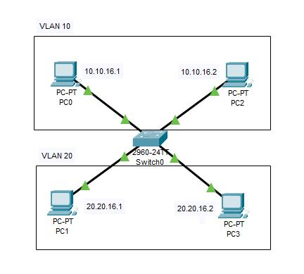

1.3 Devices
- 1 × Cisco 2960 Switch
- 6 × PCs
- 3 PCs for VLAN 10 – Sales
- 3 PCs for VLAN 20 – Accounts

1.4 IP Addressing
PC | IP Address | Subnet Mask | VLAN
PC1 | 192.168.10.11 | 255.255.255.0 | 10
PC2 | 192.168.10.12 | 255.255.255.0 | 10
PC3 | 192.168.10.13 | 255.255.255.0 | 10
PC4 | 192.168.20.11 | 255.255.255.0 | 20
PC5 | 192.168.20.12 | 255.255.255.0 | 20
PC6 | 192.168.20.13 | 255.255.255.0 | 20

For this basic VLAN exercise, no default gateway is required because communication between VLANs is not being configured.

1.5 Create VLANs
Switch> enable
Switch# configure terminal
Switch(config)# vlan 10
Switch(config-vlan)# name SALES
Switch(config-vlan)# exit
Switch(config)# vlan 20
Switch(config-vlan)# name ACCOUNTS
Switch(config-vlan)# exit

1.6 Assign Ports to VLAN 10
PC1, PC2 and PC3 are connected to Fa0/1, Fa0/2 and Fa0/3.
Switch(config)# interface range fa0/1 - 3
Switch(config-if-range)# switchport mode access
Switch(config-if-range)# switchport access vlan 10
Switch(config-if-range)# exit

1.7 Assign Ports to VLAN 20
PC4, PC5 and PC6 are connected to Fa0/4, Fa0/5 and Fa0/6.
Switch(config)# interface range fa0/4 - 6
Switch(config-if-range)# switchport mode access
Switch(config-if-range)# switchport access vlan 20
Switch(config-if-range)# exit

1.8 Save the Configuration
Switch(config)# end
Switch# copy running-config startup-config
Press Enter when the switch asks for the destination filename.

1.9 Verify VLAN Configuration
Switch# show vlan brief
Expected result:
VLAN Name Status Ports
---- -------------------------------- --------- -------------------------------
1 default active Fa0/7 Fa0/8 ...
10 SALES active Fa0/1 Fa0/2 Fa0/3
20 ACCOUNTS active Fa0/4 Fa0/5 Fa0/6

1.10 Test Connectivity
Same VLAN – communication should work:
PC1> ping 192.168.10.12
PC4> ping 192.168.20.12
Different VLAN – communication should fail in this basic Layer 2 setup:
PC1> ping 192.168.20.11
Reason: VLAN 10 and VLAN 20 are separate broadcast domains, and a Layer 2 switch cannot route traffic between them.

1.11 Important Switch Commands
Command | Purpose
enable | Enter privileged EXEC mode
configure terminal | Enter global configuration mode
vlan 10 | Create VLAN 10
name SALES | Give VLAN 10 a name
interface range fa0/1 - 3 | Select multiple switch ports
switchport mode access | Configure ports as access ports
switchport access vlan 10 | Assign ports to VLAN 10
show vlan brief | Verify VLANs and assigned ports
show running-config | Display current configuration
copy running-config startup-config | Save configuration

2. Inter-VLAN Routing Using Router-on-a-Stick

2.1 Objective
To allow VLAN 10 (Sales) and VLAN 20 (Accounts) to communicate through a router using Router-on-a-Stick configuration.

2.2 Network Topology
Router R1
+-----------+
| G0/0 |
+-----+-----+
|
TRUNK LINK
|
+-----+-----+
| SW1 |
+-----------+
/ \
VLAN 10 VLAN 20
SALES ACCOUNTS
/ | \ / | \
PC1 PC2 PC3 PC4 PC5 PC6

2.3 Devices
- 1 × Cisco 2911 Router
- 1 × Cisco 2960 Switch
- 6 × PCs
- Copper straight-through cables

2.4 IP Addressing
VLAN | Department | Network | Gateway
10 | SALES | 192.168.10.0/24 | 192.168.10.1
20 | ACCOUNTS | 192.168.20.0/24 | 192.168.20.1

Router subinterfaces: G0/0.10 = 192.168.10.1 and G0/0.20 = 192.168.20.1.

2.5 Configure VLANs on the Switch
Switch> enable
Switch# configure terminal
Switch(config)# vlan 10
Switch(config-vlan)# name SALES
Switch(config-vlan)# exit
Switch(config)# vlan 20
Switch(config-vlan)# name ACCOUNTS
Switch(config-vlan)# exit

2.6 Configure PC Access Ports
VLAN 10:
Switch(config)# interface range fa0/1 - 3
Switch(config-if-range)# switchport mode access
Switch(config-if-range)# switchport access vlan 10
Switch(config-if-range)# exit
VLAN 20:
Switch(config)# interface range fa0/4 - 6
Switch(config-if-range)# switchport mode access
Switch(config-if-range)# switchport access vlan 20
Switch(config-if-range)# exit

2.7 Configure the Trunk Port
Assume the router is connected to Fa0/24.
Switch(config)# interface fa0/24
Switch(config-if)# switchport mode trunk
Switch(config-if)# exit
Switch(config)# end
Switch# show interfaces trunk

2.8 Configure the Router
Router> enable
Router# configure terminal
Router(config)# interface gigabitEthernet 0/0
Router(config-if)# no shutdown
Router(config-if)# exit
Router(config)# interface gigabitEthernet 0/0.10
Router(config-subif)# encapsulation dot1Q 10
Router(config-subif)# ip address 192.168.10.1 255.255.255.0
Router(config-subif)# exit
Router(config)# interface gigabitEthernet 0/0.20
Router(config-subif)# encapsulation dot1Q 20
Router(config-subif)# ip address 192.168.20.1 255.255.255.0
Router(config-subif)# exit
Router(config)# end
Router# copy running-config startup-config

2.9 Configure PC IP Addresses
Device | IP Address | Subnet Mask | Default Gateway
PC1 | 192.168.10.11 | 255.255.255.0 | 192.168.10.1
PC2 | 192.168.10.12 | 255.255.255.0 | 192.168.10.1
PC3 | 192.168.10.13 | 255.255.255.0 | 192.168.10.1
PC4 | 192.168.20.11 | 255.255.255.0 | 192.168.20.1
PC5 | 192.168.20.12 | 255.255.255.0 | 192.168.20.1
PC6 | 192.168.20.13 | 255.255.255.0 | 192.168.20.1

2.10 Test Inter-VLAN Communication
From PC1, ping PC4:
PC1> ping 192.168.20.11
Expected result: Successful. VLAN 10 traffic is routed through R1 to VLAN 20.

2.11 Verify the Router
Router# show ip interface brief
Expected:
Interface IP-Address Status
GigabitEthernet0/0 unassigned up
GigabitEthernet0/0.10 192.168.10.1 up
GigabitEthernet0/0.20 192.168.20.1 up
Router# show running-config

2.12 Key Concept
Router
/ \
192.168.10.1 192.168.20.1
| |
VLAN 10 VLAN 20
SALES ACCOUNTS
The trunk link carries both VLAN 10 and VLAN 20 traffic, while the router subinterfaces perform routing between the two VLANs.

3. VLAN with DHCP
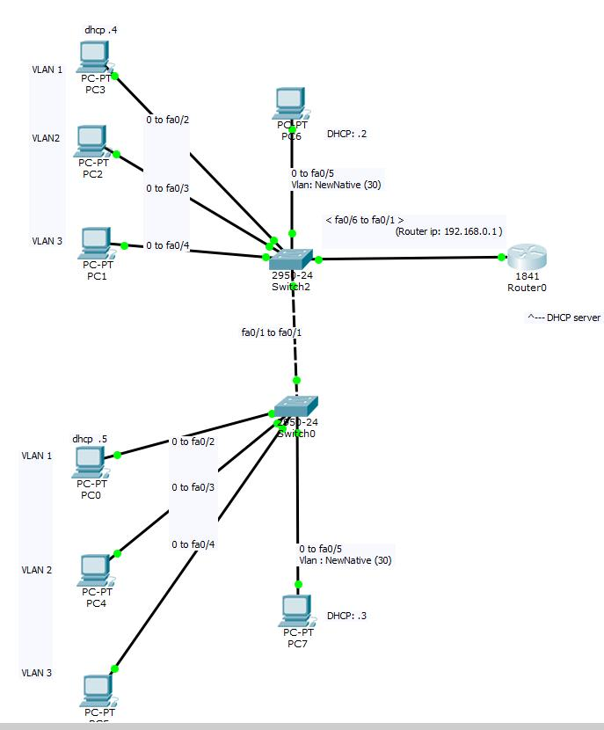

3.1 Objective
To configure VLAN 10 and VLAN 20 with DHCP so that the router automatically assigns IP addresses, subnet masks, default gateways, and DNS information to PCs in each VLAN.

3.2 Topology
R1 Router
+-----------+
| |
| G0/0 |
+-----+-----+
|
TRUNK LINK
|
+-----+-----+
| SW1 |
+-----------+
/ \
VLAN 10 VLAN 20
SALES ACCOUNTS
/ | \ / | \
PC1 PC2 PC3 PC4 PC5 PC6

3.3 VLAN and DHCP Address Plan
VLAN | Department | Network | Gateway | DHCP Range
10 | SALES | 192.168.10.0/24 | 192.168.10.1 | 192.168.10.11–254
20 | ACCOUNTS | 192.168.20.0/24 | 192.168.20.1 | 192.168.20.11–254

The router acts as the DHCP server.

3.4 Configure VLANs on the Switch
enable
configure terminal
vlan 10
name SALES
exit
vlan 20
name ACCOUNTS
exit

3.5 Assign PC Ports
VLAN 10:
interface range fa0/1 - 3
switchport mode access
switchport access vlan 10
exit
VLAN 20:
interface range fa0/4 - 6
switchport mode access
switchport access vlan 20
exit

3.6 Configure the Trunk Port
interface fa0/24
switchport mode trunk
exit
end
show vlan brief
show interfaces trunk

3.7 Configure Router Subinterfaces
enable
configure terminal
interface gigabitEthernet 0/0
no shutdown
exit
interface gigabitEthernet 0/0.10
encapsulation dot1Q 10
ip address 192.168.10.1 255.255.255.0
exit
interface gigabitEthernet 0/0.20
encapsulation dot1Q 20
ip address 192.168.20.1 255.255.255.0
exit

3.8 Configure DHCP for VLAN 10
ip dhcp excluded-address 192.168.10.1 192.168.10.10
ip dhcp pool SALES
network 192.168.10.0 255.255.255.0
default-router 192.168.10.1
dns-server 8.8.8.8
exit
PCs in VLAN 10 can receive addresses such as 192.168.10.11, 192.168.10.12, 192.168.10.13, and so on.

3.9 Configure DHCP for VLAN 20
ip dhcp excluded-address 192.168.20.1 192.168.20.10
ip dhcp pool ACCOUNTS
network 192.168.20.0 255.255.255.0
default-router 192.168.20.1
dns-server 8.8.8.8
exit
PCs in VLAN 20 can receive addresses such as 192.168.20.11, 192.168.20.12, 192.168.20.13, and so on.

3.10 Save Router Configuration
end
copy running-config startup-config

3.11 Configure PCs for DHCP
On each PC, select Desktop → IP Configuration → DHCP. Repeat for PC1 through PC6.
Example PC1:
IP Address: 192.168.10.11
Subnet Mask: 255.255.255.0
Default Gateway: 192.168.10.1
Example PC4:
IP Address: 192.168.20.11
Subnet Mask: 255.255.255.0
Default Gateway: 192.168.20.1
The exact address assigned to each PC can vary depending on DHCP lease order.

3.12 Verify DHCP
Router# show ip dhcp binding
Router# show ip dhcp pool
The DHCP binding table should display the IP addresses leased to client PCs.

3.13 Test Connectivity
Test within VLAN 10:
PC1> ping 192.168.10.12
Expected: Successful.
Test within VLAN 20:
PC4> ping 192.168.20.12
Expected: Successful.
Test between VLANs:
PC1> ping 192.168.20.11
Expected: Successful because the router performs Inter-VLAN Routing.

3.14 Complete Router Configuration for VLAN + DHCP
enable
configure terminal
interface gigabitEthernet 0/0
no shutdown
exit
interface gigabitEthernet 0/0.10
encapsulation dot1Q 10
ip address 192.168.10.1 255.255.255.0
exit
interface gigabitEthernet 0/0.20
encapsulation dot1Q 20
ip address 192.168.20.1 255.255.255.0
exit
ip dhcp excluded-address 192.168.10.1 192.168.10.10
ip dhcp excluded-address 192.168.20.1 192.168.20.10
ip dhcp pool SALES
network 192.168.10.0 255.255.255.0
default-router 192.168.10.1
dns-server 8.8.8.8
exit
ip dhcp pool ACCOUNTS
network 192.168.20.0 255.255.255.0
default-router 192.168.20.1
dns-server 8.8.8.8
exit
end
copy running-config startup-config

3.15 Overall Working Principle
PC
↓
Access Port
↓
VLAN
↓
Trunk
↓
Router Subinterface
↓
DHCP Pool
↓
Automatic IP Address

4. Practical Summary
Lab | Main Topics | Expected Result
Basic VLAN | VLAN creation, access ports, verification | Same-VLAN communication; different VLANs isolated
Inter-VLAN Routing | VLAN + trunk + Router-on-a-Stick | VLAN 10 and VLAN 20 can communicate
VLAN with DHCP | VLAN + trunk + routing + DHCP | PCs automatically receive IP configuration and can communicate across VLANs

Note: Interface names can differ depending on the router/switch model selected in Packet Tracer. If your router uses a different GigabitEthernet interface, use the corresponding interface name.

